Health Population Indicator Data Analysis  
Shuja Sajjad

1. What is the relationship between measles immunization rates and infant mortality rates?
   1. r value, visualization
2. Is there a relationship between GNP and measles immunization rates?
   1. r value, visualization

Analysis to be completed for USA, China, Germany, and Brazil.

In this project we conductive extensive data research, cleaning, and analysis of health indicator data of various countries. We decided upon using the latest data from the last decade for USA, China, Germany, and Brazil. We then calculated the statistical r values to quantify correlations between measles immunization rates, infant mortality rates, and national GNP rates.

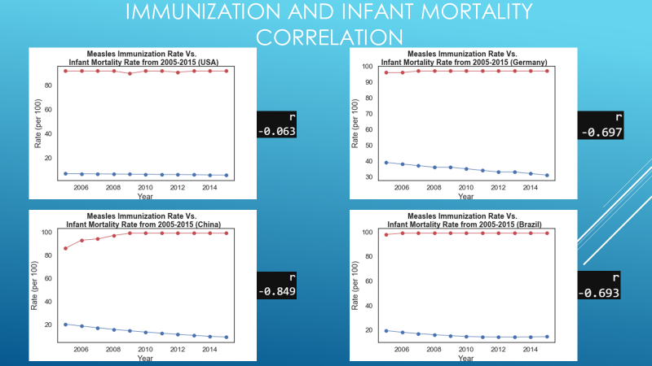

In our immunization rates vs infant mortality analysis, all four of the countries analyzed had *negative r values*, indicating that while *immunization rates increased, infant mortality rates decreased.*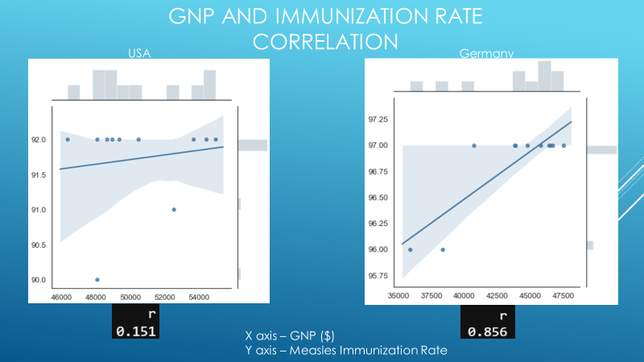 *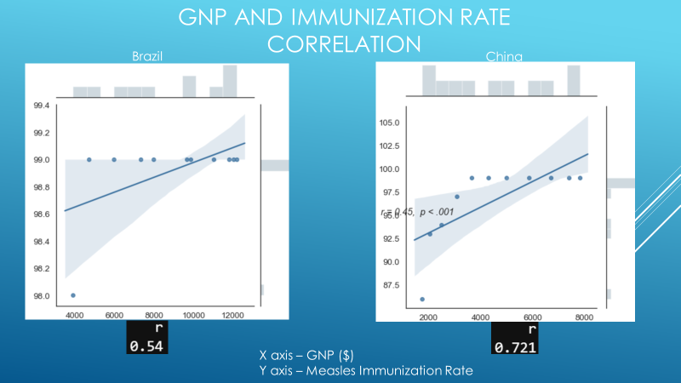*

But in our immunization rates vs GNP analysis, all four of the countries analyzed had *positive r values*, indicating that while *GNP rates increased, immunization rates also increased*.

While further research and analysis is certainly required to establish a firm causative relationship, our research and analysis provided fascinating insights into the field of global health.